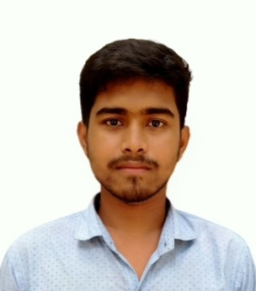**CURRICULAM VITAE**

Of

**Saikat Das**

**Cell No: +8801732835516**

**Email: saikat260498@gmail.com**

**Career Objective:**

Looking for hard and Challenging Job where I will have the scope to utilize my potentiality, adaptability and skill to do something innovate and from where I will be able to enhance my knowledge.

**Personal Details:**

Name : Saikat Das

Father’s Name : Mohanlal Das

Mother’s Name : Soivya Rani Das

Permanent Address : Lalpur, Ashuganj, Brahmanbaria

Present Address : Lalpur, Ashuganj, Brahmanbaria

Date of Birth : 26-04-1998

Sex : Male

Marital status : Unmarried

National ID : 5557298337

Religion : Hindu

Nationality : Bangladeshi

Blood Group : A+ (ve)

**Educational Qualification:**

* **Secondary School Certificate (S.S.C):**

School : [Lalpur S.K.Das Chowdhury High Schoo](https://www.facebook.com/Lalpur-SKDas-Chowdhury-High-School-200159806994815/)l

Board : Comilla

Group : Science

Passing Year : 2014

Result : 4.75

# 4 Years Diploma in Engineering:

Institute : Narsingdi Polytechnic Institute.

Board : Bangladesh Technical Education Board, Dhaka.

Technology : Computer

Session : 2014-2015

Passing Year : 2018

Result : 3.26

# 3 Years B.S.C:

University : Canadian University of Bangladesh

Department : C.S.E

Passing Year : Running

Result : 8th Semister

**Training Background:**

# Professinonal Graphic Design

Institute : Creative IT Institute

Location : Momtaz Plaza (4th Floor), Road # 04,

Houe # 07, Dhanmondi, Dhaka- 1205

Duration : 3 Months

Passing Year : 2018

**Computer Skills:**

* **Application Package** : MS Word, MS Excel
* **Graphic Design :**Adobe Photoshop, Adobe Illustrator

**Work Experience:**

Having 1 year experience as a Computer Operator in Lalpur S.K Das Chowdhury High School.

**Declaration:**

*I declare that all the information included here are true to my knowledge. If requiredand where applicable, this document can be supported by appropriated authentic certificate.*

***Saikat Das***